Project Plan (to be modified and augmented as things progress)

The goal is to build a multi-lingual search engine on ancient Cypriot secretariat corpus. It should be an intra-document search engine, but not like the ones found in PDF or Word documents. The user may give queries in English, Modern Greek or Ancient Greek. We can divide the problem into two smaller parts – (a) design of a search engine where query terms are given in Ancient Greek (A. Gr.), and (b) improving upon the A. Gr. search engine to include English (En.) and Modern Greek (M. Gr.) query input functionality.

- Design Decisions for Part (a)
- What should be the unit of retrieval?
In Google, each search result points to a webpage. In this case we have no webpages to display. There are 5 flat volumes of text. We can, however, conceive each page as a webpage, and display the pages as search results. A refinement on this might be to show paragraphs as search result, but a better idea should be to display the paragraphs as snippets rather than results, like Google Books. The paragraphs may also be highlighted for convenience when showing the actual page. It will depend on the structure of the books as well. We need to investigate the structure.
- What should be the ranking function?
This is a much harder issue. We can expect that user click data will ultimately enable us to pinpoint the types of query senses and the best ranking criteria implied thereof, but initially we must supply the user with an intelligible means of satisfying his/her information need. While the effects of conventional measures like BM25 need to be investigated, we may also encounter new problems mandating the use of new measures of ranking. Query will play a crucial role here. As an example, ranking of places should be based on different criteria than ranking of person names. Query classification based on A. Gr. Ontology will be useful here.
- What about disambiguation?
The same term may mean different things (polysemy) and we need to take care of that. For example, “Jaguar” may either mean an animal or a car brand. In these cases, we need to display the results pertaining to both categories, preferably in two sections. The term “Virginia”, for example, may either mean the name of a woman, or the name of a place. Ancient documents may contain reference to the first meaning, but not to the second. We will do word-sense disambiguation to handle these queries.
- Issues of Synonyms and Hyponyms
We need to deal with synonyms and hyponyms (or hypernyms) in Ancient Greek. Since relevance to the end user is key issue, we need to see if we can obtain more relevant results by putting synonyms and hyponyms as query. Another leeway is to put a disjunction of the original query, the synonyms and the hyponyms as an augmented query.
- Query classification
The same query may mean multiple objects, e.g. “Virginia” as a place or person. A phrase query may also lead to multiple interpretations (although phrase translation usually implies less room for ambiguity). In all such cases, we will do query classification to see whether the query falls into a particular group or type. Some pre-defined classes might be obtained from the document ontology, like person, place, time, organization, etc. We also need to investigate whether query clustering is more appropriate here than classification.

- Design Decisions for Part (b)
Part (b) comprises the design of English and Modern Greek query input functionality. First of all, we need to decide whether the query should be translated to A. Gr., or the documents should be translated to M. Gr. (or English). Turns out we need to do both. It is certainly more meaningful and efficient to translate the query from M. Gr. Or Eng. To A. Gr., and then index the A. Gr. term. This helps avoid the semantic losses typically associated with document translation. Although we still incur some loss in translating a query, it is not as heavy. The user part of this loss is unavoidable, because query can never be precise. By “precise” we mean the query should exactly encode the information need – no more and no less. This precision is rarely achieved in practice. On the other hand, there will be some loss in translating the query as well, but we can guard against that. For example, Google has introduced a new feature in its Advanced Search functionality. Here a user can suggest different translations for the same query, and possibly obtain better and more relevant search results. There are other techniques like query expansion (before and after translation). Expansion before translation helps increase precision and expansion after translation helps increase recall.

There is a need to translate A. Gr. documents to M. Gr. and/or English. The user may not be familiar with A. Gr. (or M. Gr.). In this case, presenting a bunch of A. Gr. results to him/her will serve no purpose. We need to present two sets of results – the original A. Gr. pages, and their translated versions. The translations will never be perfect, but they should be sufficiently indicative of what the document is about. The translated snippets should also be meaningful. We need to consider whether we should generate snippets from translated documents, or translate original snippets. The latter might be more intelligible (need to investigate).

Roughly, we should present the user with something like the following screenshot:
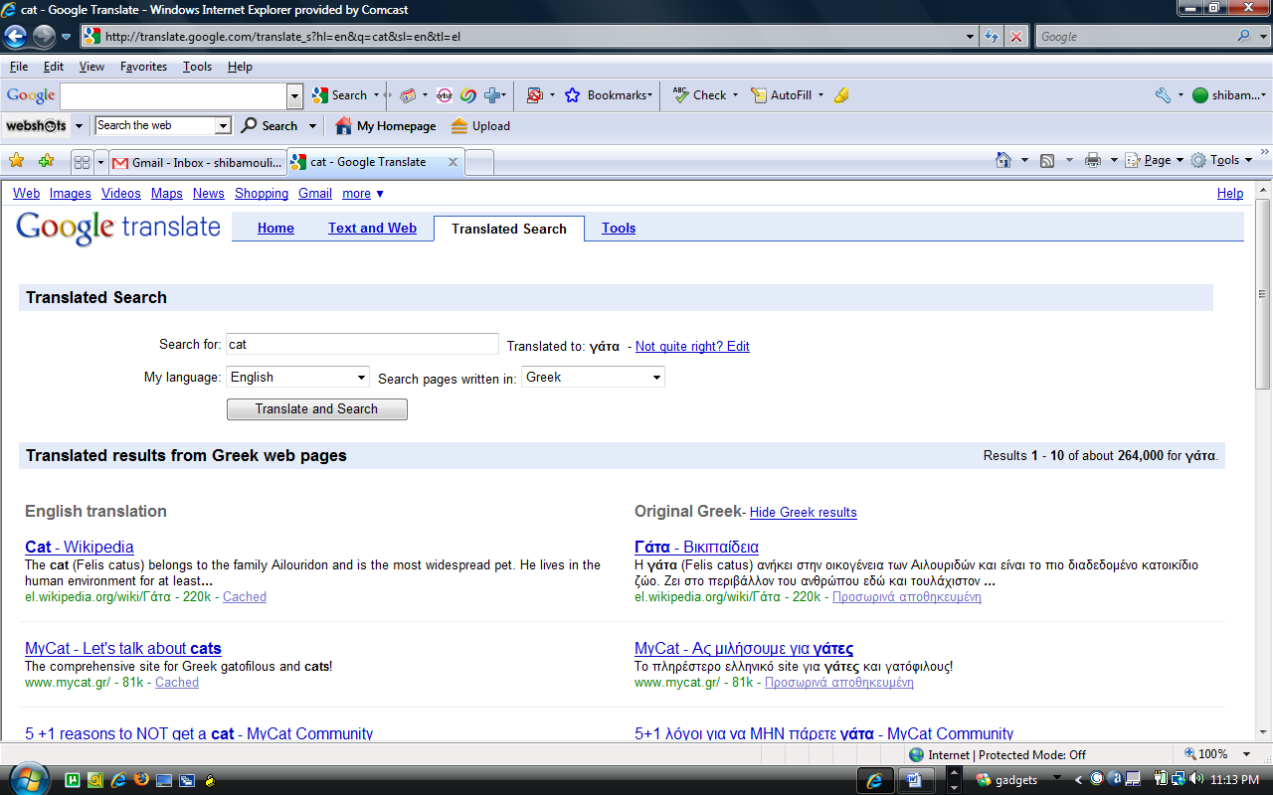
Here we have two columns of search results – English (translated) and Greek. In our case we should have three columns – English (translated), Modern Greek (translated) and Ancient Greek (original). Clicking on each search result will give the user an appearance like Google Books with relevant passages (paragraphs?) highlighted. Here we see the need for translating the documents. We’ll have to deal with two pairs of translations:
A Gr. < –> M. Gr. and A. Gr. <–> Eng., whereas Google deals with only one pair.
We need to know whether there exist significant differences between Ancient and Modern Greek. It seems that apart from capitalized usage of characters and a different phonetic scheme, Ancient Greek is almost same as Modern Greek. In fact, Ancient Greek has been cited as easier than Modern Greek. So we may not really need a translator for Ancient to Modern Greek and vice versa (need to investigate).

